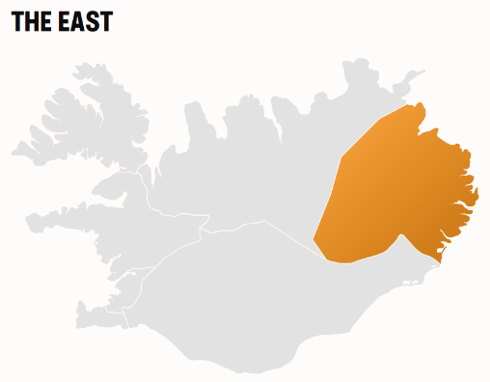Discover the wonders of East Iceland, home to the country's largest forest, lush farmlands and an assortment of streams and mountains. Thanks to the East's fjords and their natural harbours, a variety of picturesque fishing villages border the coast.

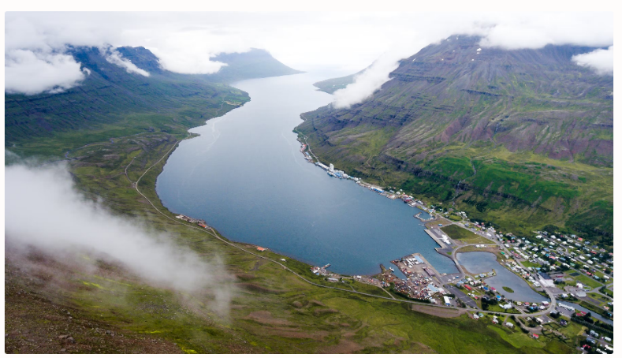

### FANTASTIC SCENERY

There is so much to explore in East Iceland. Iceland's biggest rhyolite formations directly accessible from an inhabited area are those around Borgarfjörður Eystri, while impressive magma chambers filled with colourful mineral deposits can be seen and visited along the eastern coast. In the summer months, the east of Iceland becomes a creative hub for artists and young people from around Iceland and abroad, as a variety of music and art festivals have been popping up and expanding steadily in recent years.

The hiking and riding possibilities are also numerous, including across extensive but well-mapped uninhabited areas. Winter tourism, for instance skiing or driving on snow, is also important.

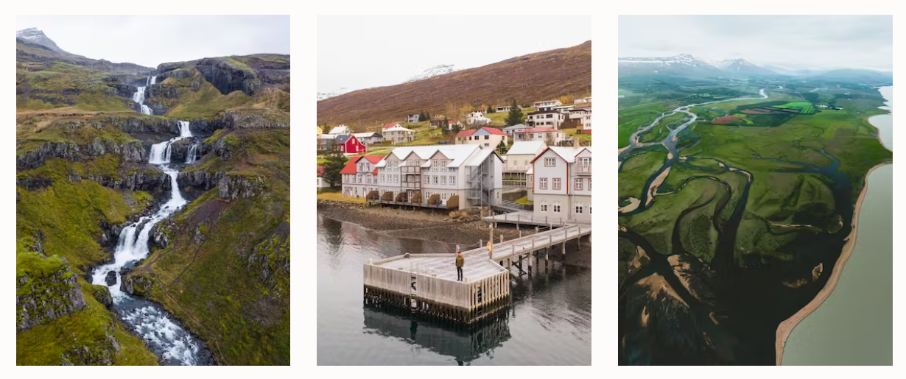

#### **ENJOYING EAST ICELAND**

Seyðisfjörður is the landing place for the [Smyril Line ferry](https://www.visiticeland.com/article/ferry-to-iceland)from Europe, and home to a vibrant art scene emerging to the backdrop of a 19th century village. Indeed, the East has a rich artistic history, as the landscape in the region is truly a rich palette. One of Iceland's most beloved artists, the painter Jóhannes Sveinsson Kjarval, grew up in the town of Borgarfjörður eystri, where he created some of his most memorable work and where a museum now commemorates his life.

The East is also home to several interesting arts and music festival throughout the year. In the southeast, the Vatnajökull Glacier—Europe's largest—is an imposing, spectacular sight.

Egilsstaðir is the largest town in East Iceland. There are daily flights from the domestic airport in Reykjavík to Egilsstaðir. It is also possible to drive from Reykjavík to Egilsstaðir and also the general Eastern region of the country. In fact, driving to East Iceland provides an exciting opportunity as one can drive through either South Iceland or North Iceland to get to this unique part of the country.