**English**

Create your own bad character that could replace the Big Bad Knight.

Draw a picture of them then write a description of what they look like on the inside and on the outside.

Example:

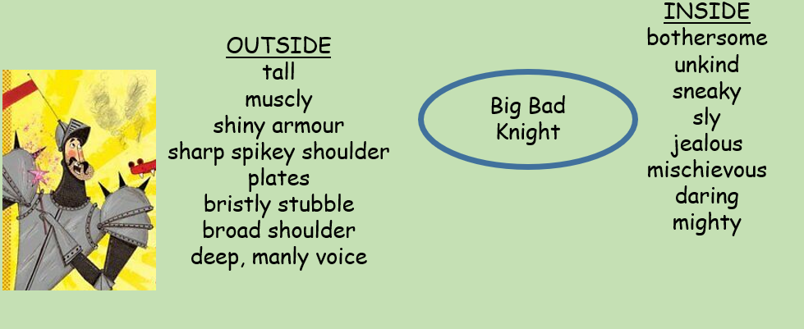

A towering figure in polished gun metal grey armour, the Big Bad Knight is an imposing and fearsome sight. His shoulders are adorned with jagged, spiked details, accompanied by a bristly stubbled chin. His demeanour is as cold as the steel he wears, and he moves with a heavy, deliberate grace that suggests both power and menace. Every step he takes seems to shake the ground, and his deep voice rumbles like thunder.

Good luck. You can bring in your picture and writing of your character and share with your teacher.