Recapping what you did on Friday, find the previous & next multiple of 10 and then 100.

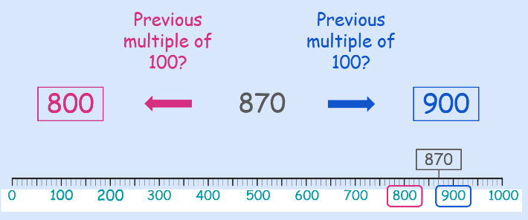

|  |  |  |
| --- | --- | --- |
| Previous multiple of 10 | Number | Next multiple of 10 |
| 80 | 85 | 90 |
|  | 27 |  |
|  | 93 |  |
|  | 61 |  |
|  | 64 |  |
|  | 18 |  |
|  | 274 |  |
|  | 191 |  |
|  | 389 |  |
|  | 842 |  |
|  | 814 |  |
|  | 311 |  |
|  | 606 |  |
|  | 921 |  |

|  |  |  |
| --- | --- | --- |
| Previous multiple of 100 | Number | Next multiple of 100 |
| 500 | 550 | 600 |
|  | 770 |  |
|  | 920 |  |
|  | 410 |  |
|  | 240 |  |
|  | 150 |  |
|  | 642 |  |
|  | 994 |  |
|  | 407 |  |
|  | 618 |  |
|  | 845 |  |
|  | 113 |  |
|  | 888 |  |
|  | 923 |  |