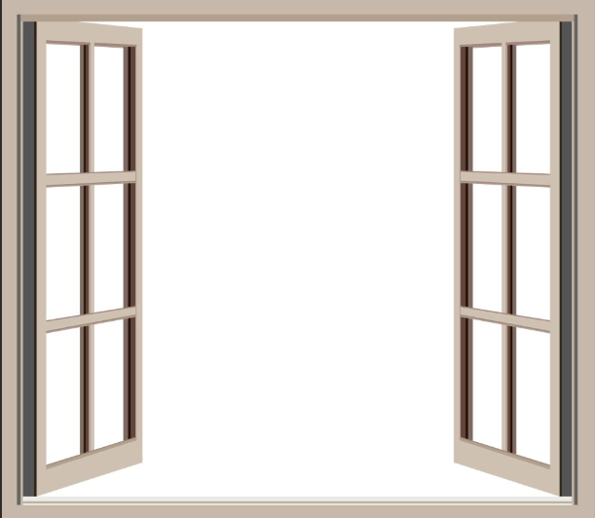

As geographers this term we have been looking at our local area and how the view is changing.

Create a picture of what your view looks like from one of your windows.