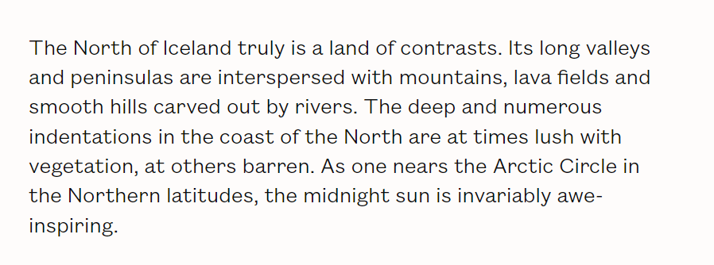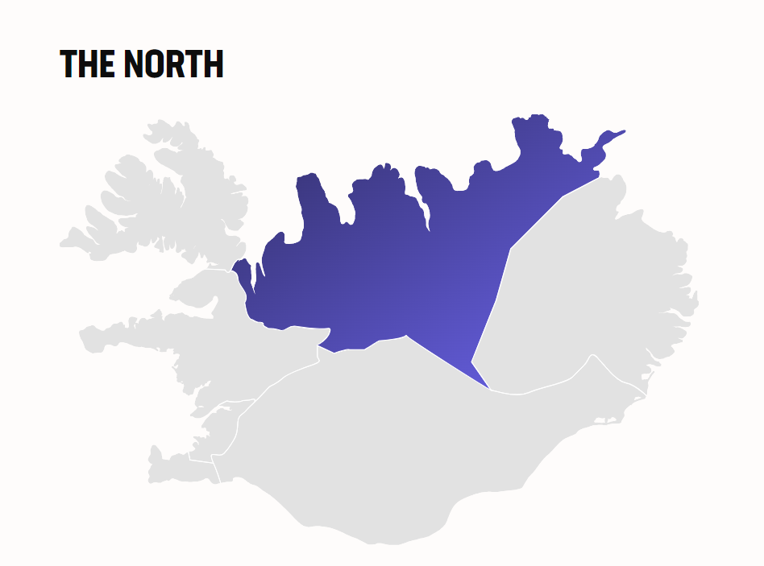

**STUNNING DESTINATIONS OF THE NORTH**

Many towns of the North are dedicated to marine life. The Húsavík Whale Museum and the Seal Center in Hvammstangi are two options for visitors. Close by in the northern reaches of the Vatnajökull National Park is the impressive Ásbyrgi Canyon, as well as the Dettifoss Waterfall—the most powerful in Europe. The nearby Lake Mývatn and its surrounding wetlands has an exceptional variety of waterbirds and rock formations.

The North is home to Iceland's second largest urban area, Akureyri, located in Iceland's longest fjord, the mild-weathered Eyjafjörður. Akureyri, rich in culture and history, has a charming downtown full of late nineteenth century wooden houses. In summer, golfers can take advantage of the midnight sun at the Arctic Open. North Iceland is also home to many historic coastal towns.

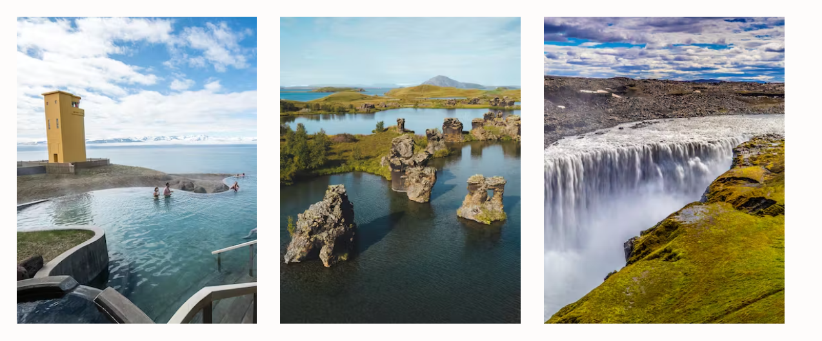

#### **TRAVEL THE ARCTIC COAST WAY**

Travelling the Arctic Coast Way means leaving the common routes behind you and going off the beaten track to discover some of the most remote places in North Iceland; a unique adventure following 900 km of coastal roads close to the Arctic Circle.

The Diamond Circle can be described as a magnificent circuit of 250km in the Northeast of Iceland, which includes some of the most stunning sights and spots for unearthly landscapes.

The Diamond Circle has 5 key destinations which include the historical and picturesque Goðafoss, the unearthly blue and green landscapes of Lake Mývatn nature paradise, the uncontrollable white energy of Dettifoss the most powerful waterfall of Europe, the crescent-shaped wonder of Ásbyrgi canyon and Húsavík the buzzing whale watching capital of Iceland with the deep blue seas ahead.