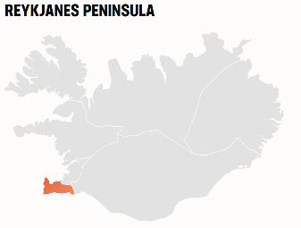The Reykjanes peninsula is a geological wonder, where lighthouses outnumber villages. Besides hosting the Keflavík International Airport and, just a few minutes away, the spectacular Blue Lagoon, and the Fagradalsfjall volcano, the Reykjanes peninsula is a destination in its own right.

#### THE HOTTEST DESTINATION IN ICELAND

Reykjanes peninsula is replete with natural marvels, in addition to the renowned [Blue Lagoon](https://www.bluelagoon.com/) and an array of lighthouses.

As travelers touch down at Keflavik International Airport, visitors are greeted by a moon-like landscape. Unless hidden by snow, a seemingly endless lava field topped with green-grey moss blankets much of the Reykjanes peninsula, and this rather other-worldly sight turns out to be most people's first glimpse of Iceland, the land of fire and ice.

Reykjanes has several high-temperature geothermal areas, three of which have been harnessed to generate electricity. In the [Geothermal Energy Exhibition](https://www.on.is/en/geothermal-exhibition/) in the Hellisheiði lava fields, visitors can learn not merely about geothermal power but also local geological history.

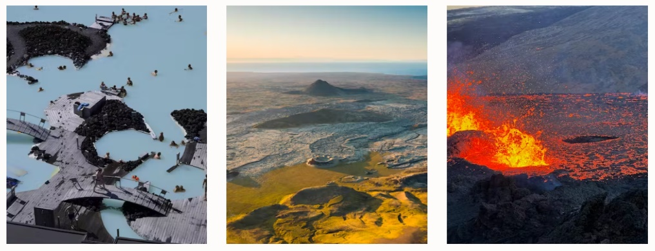On the Reykjanes peninsula, the junction between the Eurasian and North-American tectonic plates of the earth's crust is more noticeable and comprehensible than anywhere else. Thus it is no wonder that the peninsula has now been designated as the [Reykjanes Geopark](https://reykjanesgeopark.is/), which besides being a landscape to admire and study is also a veritable hotbed of recreational activities.

#### THE YOUNGEST PART OF ICELAND

The Fagradalsfjall volcano started erupting on March 19 2021 and with six months of activity, created a small volcanic shield covering an area of 5 km2. The beautiful crater and lava formations are one of Iceland's hottest destinations and are easily accessible if weather and conditions are favorable on the mountain. Then there was an eruption at almost the same location in August 2022, and again in July 2023, both of which lasted for a much shorter period, or around three weeks.

**Since October 2023 there has been increased seismic activity in the Reykjanes area, which might indicate an upcoming volcanic eruption.**

#### REYKJANESBÆR MUNICIPALITY INCLUDES THE KEFLAVÍK AND SMALL FISHING VILLAGES

Reykjanesbær is the biggest municipality on the Reykjanes peninsula and includes several harbors and villages. The museum [Viking World](https://www.vikingworld.is/) displays a seafaring replica of the famous Gokstad ship and informs the visitor of many aspects of Viking life, in addition to offering splendid views of the Atlantic. The locality takes pride in being the cradle of Icelandic pop and rock music, a genre which can be handily explored at the [Museum of Rock 'n' Roll.](http://www.rokksafn.is/en)

#### TAKE YOUR TIME TO ENJOY REYKJANES

For most visitors to Iceland, the Reykjanes peninsula welcomes them as they usually land in [Keflavík airport](https://www.isavia.is/en/keflavik-airport" \t "_blank). The endless lava fields, craters and treeless environment is a unique way to be welcomed to the country. The whole Reykjanes Peninsula is a [UNESCO Global Geopark](https://en.unesco.org/global-geoparks/reykjanes), a cultural, geographical and historical treasure trove and as such is worthy of exploration.