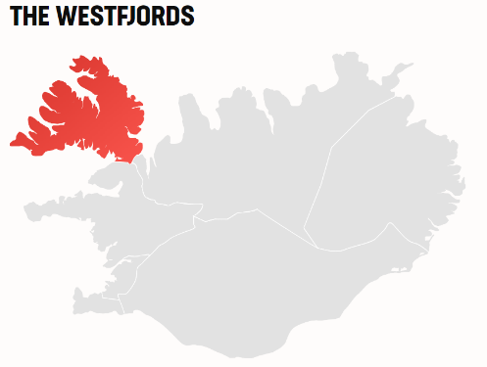One of Iceland's best-kept secrets is undoubtedly the country's northwest corner, named the Westfjords. Isolation and sparse population have preserved the unspoiled nature of the Westfjords and Icelandic folklore culture. Travel guides frequently designate the Westfjords as a destination of excellence. The Westfjords are certainly a must-see for any serious explorer.

#### **LONELY PLANET'S TOP 1 TRAVEL DESTINATION IN 2022**

The Lonely Planet travel guide has recognized The Westfjord's uniqueness and listed the region [No. 1 on the list for Best in Travel in 2022.](https://www.lonelyplanet.com/articles/best-in-travel-2022)

"The Westfjords is where Iceland's dramatic landscapes come to a riveting climax and where mass tourism disappears – only about 10% of Iceland's visitors ever see the region."

Tourism in the Westfjords has grown slowly and organically, with sustainability as a guiding light in the process. With great ambition, the area has since 2016 been [certified by EarthCheck as a sustainable travel destination](https://earthcheck.org/news/2016/november/inspiring-stories-from-the-westfjords-of-iceland/)

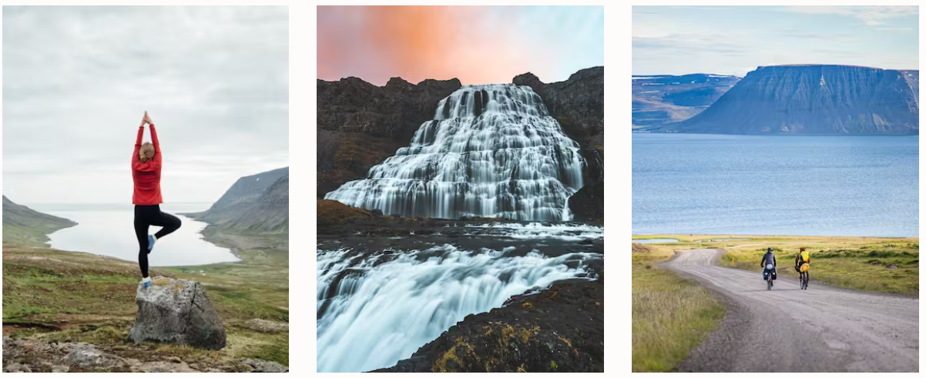

Travel companies in the Westfjords are mostly family-run by former farmers or fishers. As a result, young people now see opportunities in tourism that ables them to continue living in their remote home region, where many before have had to relocate since jobs in the fishing industry have declined in the past decades.

One of the most [sustainable ways to travel in Iceland](https://www.visiticeland.com/sustainable-travel/)is, therefore, to visit regions like The Westfjords and support the communities there.

The Westfjords peninsula is a true Icelandic wilderness area and undoubtedly the ideal place for spotting birds and arctic foxes in their natural habitats and exploring the dainty sub-arctic flora of Iceland.

The Hornstrandir nature reserve is a backpacker's paradise located in the Westfjords' northwestern corner. The remote, uninhabited peninsula is a haven for birds, plants, and Iceland's only native mammal, the Arctic fox.

##### ONE OF EUROPE'S LARGEST BIRD CLIFFS AND WESTERNMOST POINTS

Látrabjarg, on the southwest side of the Westfjords, is Europe's largest bird cliff and home to over a million seabirds, including puffins, guillemots, and the largest razorbill colony in the world. The bird cliff is a breeding area for up to half of some of the species world populations and is therefore listed as an internationally important bird area (IBA) and a nature reserve. Látrabjarg is also the westernmost point of Iceland and one of Europe's westernmost outposts.

#### **STRONG TIES TO CULTURAL HERITAGE AND TRADITIONS FROM FISHING CULTURE**

Tradition and heritage play a large role in the region's culture. The strong relation to the ocean is evident in the regional cuisine, and folklore is as much alive in the Westfjords as anywhere else in Iceland.

[The museums in the Westfjords](https://www.visiticeland.com/article/the-museums-of-the-westfjords)are known for their creative approach, with museums dedicated to sorcery and witchcraft, everyday things, and monsters and creatures from the sea.

The Westfjords Way (Vestfjarðaleiðin) will take you through a landscape found nowhere else on earth, along peaceful coasts, through tunnels of all sorts, down steep, dramatic mountain roads, over tiny, charming bridges, and along beaches with sand of all colors.

Be prepared for the immense and immersive part of Icelandic nature in its own charming and welcoming way. The route through the Westfjords and the Dalir district in West Iceland.

The Westfjords Way is a touring route that navigates you 950 km through the Westfjord‘s rough and dramatic landscape. This route is filled with twists and turns in every sense of the word and will give you a taste of what Iceland off the beaten track has to offer. [Find out more](https://www.visiticeland.com/article/the-westfjords-way)

#### GETTING THERE

Despite being a remote region of Iceland, the Westfjords are quite accessible.

There are [daily flights to Ísafjörður](https://www.icelandair.com/flights/isafjordur/), the Westfjord's largest town, available all year round, as well as [flights to Bíldudalur](https://www.norlandair.is/en)several times a week.

[Public transport](https://straeto.is/en)is also available year-round between Reykjavík and Ísafjörður, but please be aware of seasonal changes. The [Westfjords Adventures](https://westfjordsadventures.com/bus-schedule/" \t "_blank)offers bus rides within the Westfjords in spring and summer.

Driving allows more flexibility while exploring the region, and the area is well covered with [gas stations](https://www.google.com/search?rlz=1C5CHFA_enIS963IS963&tbs=lf:1,lf_ui:3&tbm=lcl&sxsrf=AOaemvI5CL1VtWss4MjvhDLnKp80p-ez8g:1639398741241&q=gas+stations+westfjords&rflfq=1&num=10#rlfi=hd:;si:;mv:[[66.91932114500774,-15.212817103591984],[64.71321570811031,-26.001391322341984],null,[65.83992687730974,-20.607104212966984],8])and [fast-charging stations](https://www.google.com/search?q=charger+stations+westfjords&rlz=1C5CHFA_enIS963IS963&tbm=lcl&sxsrf=AOaemvIULhfAhE8ClpPtQiSROjg8v5uHDg%3A1639398907054&ei=-z23Yc2-Ao7dgQbHlqww&oq=charger+stations+westfjords&gs_l=psy-ab.3...16599.16599.0.17458.1.1.0.0.0.0.142.142.0j1.1.0....0...1.1.64.psy-ab..0.0.0....0.15gXn0xzTyY#rlfi=hd:;si:;mv:[[66.95186312504467,-15.792477967187487],[64.74867358826891,-26.581052185937487],null,[65.8739018215185,-21.186765076562487],8])for electric vehicles. The distance between Reykjavík and Ísafjörður is 455 km on a paved road.

A [car ferry from Stykkishólmur to Brjánslækur](https://www.seatours.is/excursions/brjanslaekur/)on the southern part of the Westfjords operates daily throughout the year.

The spectacular Dynjandi, a set of waterfalls with an accumulated height of 100 meters, is a must-see.