**Year 4 Home Learning 25th November 2024**

Maths – Perimeter

**What is Perimeter?**

Perimeter is the distance around the outside of a shape.

It can be measured in cm, inches, feet, yards, km, miles, etc.

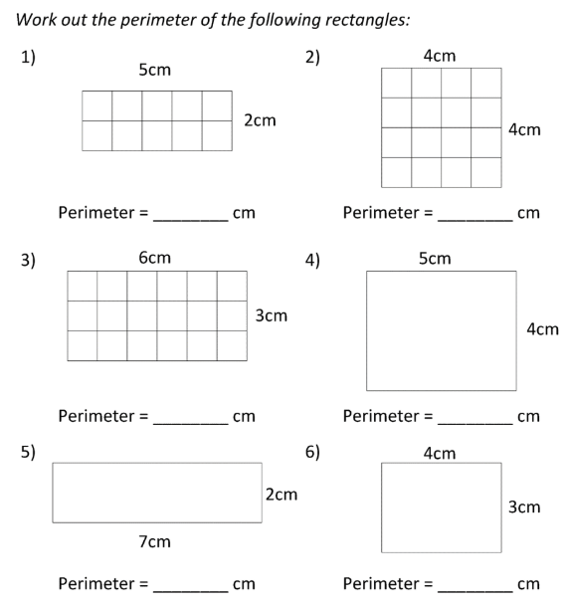A good way of thinking about the perimeter of a shape in front of you is to imagine that you are very small and standing on one of the corners of the shape. Imagine walking along the sides of the shape until you get back to where you started. The distance you have walked will be the perimeter! Have a go at the following questions:

**Mr Strong** – Find 5 items in your house and measure the perimeter of them! Use a tape measure or ruler, but if you don’t have anything then you could use your hands or feet. Design a table with your results. As an added challenge, try turning your results into a bar chart like the ones we made in geography.

English – Prepositional Phrases

What is a preposition?

A preposition is a word that tells you where or when something is in relation to something else. Examples of prepositions include words like 'after', 'before', 'on', 'under', 'inside' and 'outside'.

The house was on the hill beside a tree.

In this sentence 'on' and 'beside' are prepositions which show you exactly where the house was.

What is a prepositional phrase?

A prepositional phrase is a group of words that includes the **object** that the **preposition** refers to, and any other words that link it to the preposition.

An example could be: **Beyond the trees**, Roz saw a gnarly, burnt tree.

Today, can you look around your house to complete these sentences and then write some of your own! Describe what you find with at least one powerful adjective.

Under the bed, I can see…

In the fridge, I can smell…

Behind the door, I can hear…

Now, using the following prepositions to help you, write 5 of your own sentences about what you find around your house using your sense to help you.

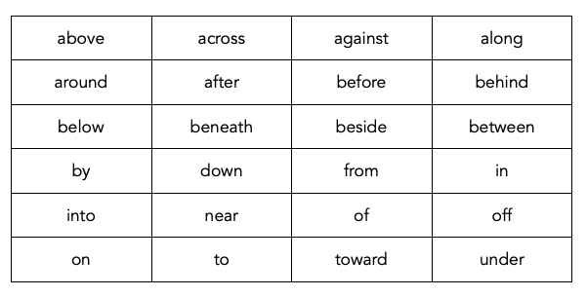

Geography

In Geography, we have been learning about sustainability linking to our learning about ‘The Wild Robot’.

**Sustainability** is the idea that humans must interact with the environment in a way that ensures there will be enough resources left for future generations.

Today, we would like you to adapt your own home to make it more sustainable! Draw/paint/build and label a picture of your home to make it as sustainable as possible. Here’s an idea to help you:

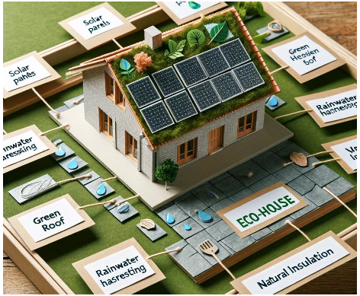

You could use pens, LEGO, junk modelling – whatever you like!

Extras

Please continue to practice your spellings on Spelling Shed and your times tables on TT Rockstars. You can also enjoy some reading time too.

**For an extra creative challenge, why not create your own Christmas decoration to bring into school and put up in the classroom!**