**Year 4 Home Learning 26th November 2024**

Maths – Perimeter

**What is Perimeter?**

Perimeter is the distance around the outside of a shape.

It can be measured in cm, inches, feet, yards, km, miles, etc.

A good way of thinking about the perimeter of a shape in front of you is to imagine that you are very small and standing on one of the corners of the shape. Imagine walking along the sides of the shape until you get back to where you started. The distance you have walked will be the perimeter! Have a go at the following questions:

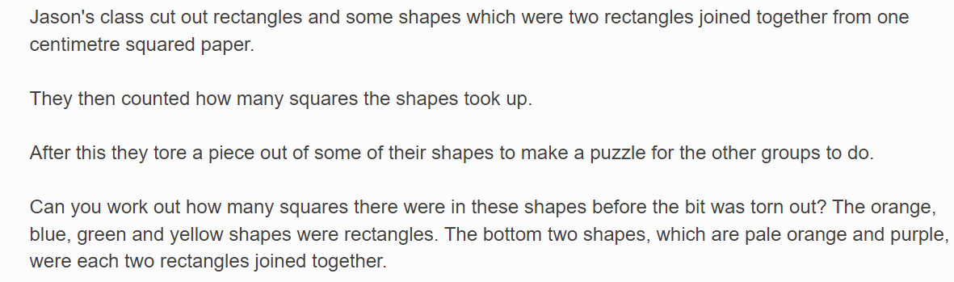

**Have a go at the following maths challenge involving perimeter!**

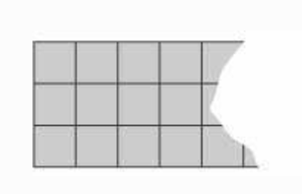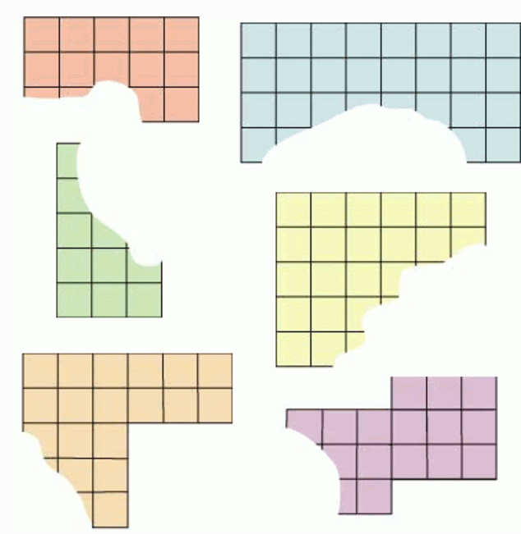

**MR STRONG**

**Courtney's group tore too much off their grey rectangle!**

What is the smallest number of squares it could have had?

What is the largest number of squares it could have had if it was not longer than the longest of the other shapes?

English – Prepositional Phrases

What is a preposition?

A preposition is a word that tells you where or when something is in relation to something else. Examples of prepositions include words like 'after', 'before', 'on', 'under', 'inside' and 'outside'.

The house was on the hill beside a tree.

In this sentence 'on' and 'beside' are prepositions which show you exactly where the house was.

What is a prepositional phrase?

A prepositional phrase is a group of words that includes the **object** that the **preposition** refers to, and any other words that link it to the preposition.

An example could be: **Beyond the trees**, Roz saw a gnarly, burnt tree.

Today, we’re going to apply our learning from yesterday to create a paragraph of writing about one of the pictures on the next page. Try to link your powerful description together using prepositions. Aim to write about half a page.

*For example,*

*In the forest was an ancient, gnarly tree. At the base of the tree lived a family of fluffy foxes beside a sparkling, blue river. Across from the river, flocks of colourful birds sang loudly in the morning sun*

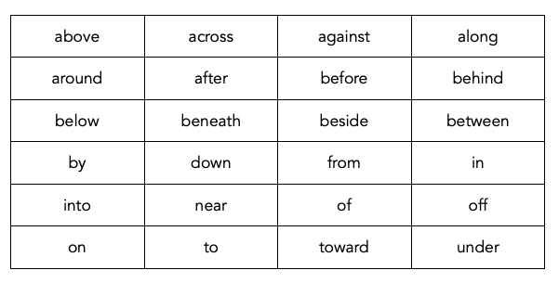Use the prepositions again to help you link your ideas together.

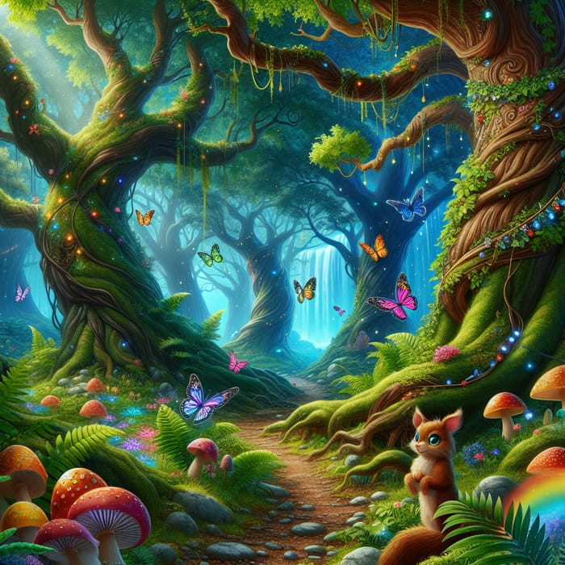

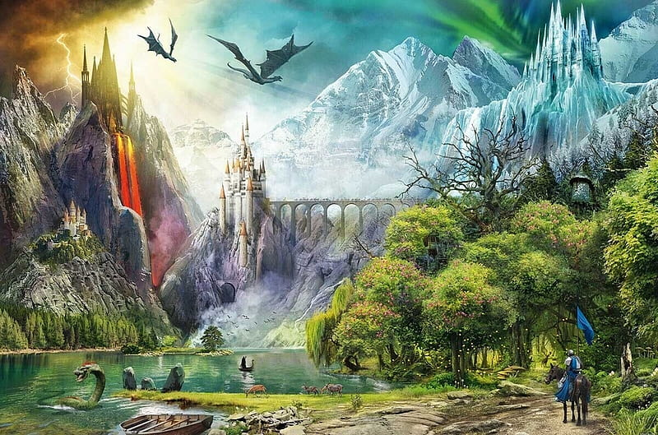

Science – Electricity

Choose some electricity activities from the grid below to try for yourself at home:

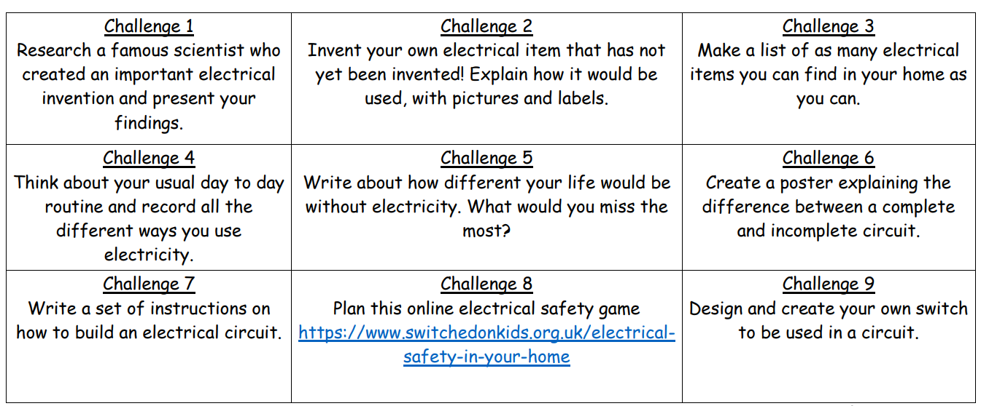

Extras

Please continue to practice your spellings on Spelling Shed and your times tables on TT Rockstars. You can also enjoy some reading time too.

**For an extra creative challenge, why not create your own Christmas decoration to bring into school and put up in the classroom!**