#### Reykjavík is the natural starting point for any visit to Iceland, and not undeservedly so. The capital is world-renowned for its culture, history, and natural beauty on all fronts.

#### A CITY OF BOLD CONTRASTS

Downtown Reykjavík is Iceland's nucleus of Iceland's culture and arts scene. By day, the café culture rules supreme, with the lively hum of conversations. As evening arrives, people start filling into the city's excellent restaurants, where local ingredients are served with fresh delicious lamb, seafood or wild game.

Reykjavík is a city of bold contrasts: it is both cosmopolitan and small-town; vibrant and sophisticated; young-at-heart and yet full of history. Many monuments, new and old, are also worth a peek, including the newly built oceanfront music and conference centre, Harpa. Luckily, everything in Reykjavík is close by, museums, galleries, theatres, cafés and swimming pools for example. As such, the city is perhaps best explored by foot or bike.

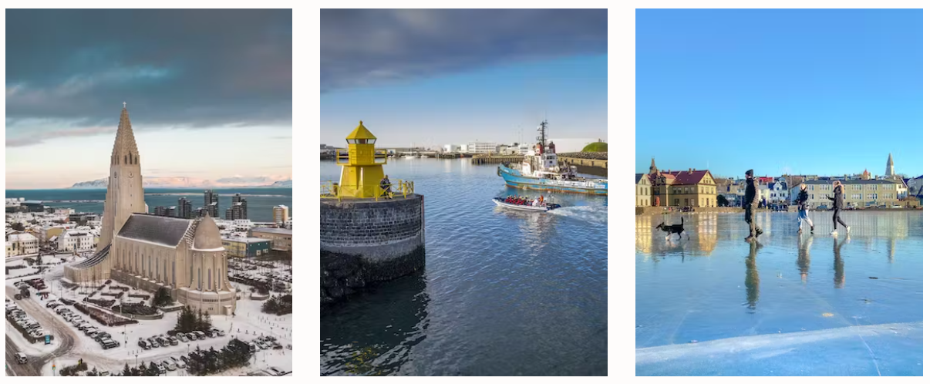

#### THE PERFECT PLACE FOR A MINI-BREAK

The pulsing beat of energy and lively events keeps Reykjavík alive and exciting and people are often surprised and impressed at how much culture, art and activities thrive in the city. But besides being world-renowned for it's vibrant culture, Reykjavík is truly the gateway to Iceland. The capital area has enough natural wonders at its doorstep to serve as a convenient base for exploring a great deal of spectacular landscape in several directions.

From the city, many day trips can also be taken to the surrounding mountains, glaciers, volcanoes and hot springs. Day-excursions from Reykjavík include horseback riding, glacier climbing, river rafting, caving, whale watching, and more.