**North Iceland**

* long valleys with mountains, lava fields and smooth hills carved out by rivers
* Lush vegetation
* Whale museum and seal centre
* Most powerful waterfall in Europe
* Beautiful landscape
* Rich history

**North-Western Iceland**

* Boat trips
* Has the longest Fjord in Iceland
* Puffins
* Museums
* 2nd largest city is found here
* Most stable weather

**Westfjords**

* Many Waterfalls
* Kayaking, Skiing and Fishing
* Mountainous
* Approximately 7,115 people live here
* Can see the Northern Lights from here

**West Iceland**

* Volcanoes, waterfalls and hot springs
* Lava Tube Cave
* Hiking in forests
* Glaciers and fjords

**East Iceland**

* Rich artistic history
* Lots of music and art festivals
* Popular with tourists – daily flights
* Lots of lakes and rivers
* Magma chambers full of minerals and crystals
* In summer, many tourists from Iceland and abroad visit here

**North Iceland**

* long valleys with mountains, lava fields and smooth hills carved out by rivers
* Lush vegetation
* Whale museum and seal centre
* Most powerful waterfall in Europe
* Beautiful landscape
* Rich history

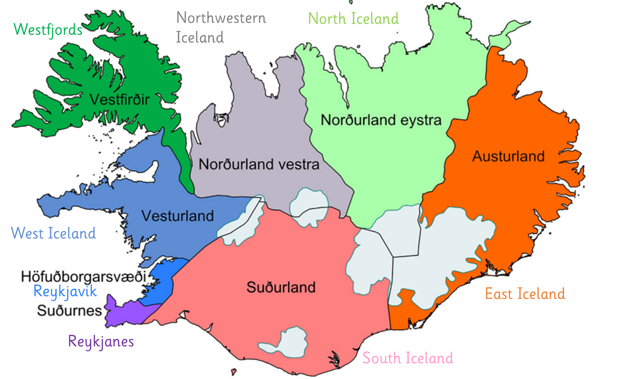

**Reykjavik**

* Many trees
* Largest city on Iceland
* Museums
* Has a port
* 230,000 people live here
* Only capital where you can see the Northern Lights

**South Iceland**

* Mountains, valleys, volcanoes
* Famous for sea food such as lobster
* Hot springs, geysers and spas
* Beaches – kayaking tours

**East Iceland**

* Rich artistic history
* Lots of music and art festivals
* Popular with tourists – daily flights
* Lots of lakes and rivers
* Magma chambers full of minerals and crystals
* In summer, many tourists from Iceland and abroad visit here