#### West Iceland is one of Iceland's most geologically diverse regions. Its natural wonders are a nearly exhaustive sampling of all that Iceland offers, ranging from slumbering volcanoes and majestic waterfalls to various flora and wildlife.

#### CLOSE TO THE CAPITAL AREA, BUT A COMPLETELY DIFFERENT EXPERIENCE

Around West Iceland, history is everywhere to be discovered. It is a world where culture, nature and history complement each other, creating a unique experience. This vast area consists of fjords, valleys, craters, glaciers and volcanoes, with magnificent waterfalls, hot springs and caves to explore.

Great hikes are found around Akranes and Hvalfjörður, with the mountain Akrafjall and the highest waterfall in Iceland Glymur less than an hour from Reykjavík. Visit the homestead of medieval writer Snorri Sturluson at Reykholt, and see the man-made geothermal bath in which he must have often allowed his mind to wander. Dive into the [Krauma geothermal bath](https://krauma.is/" \t "_blank)in water from Europe's most powerful hot spring, Deildartunguhver. Or learn about the awe-inspiring Viking poet Egill Skalla-Grímsson in Borgarnes. A visit to the otherworldly [Víðgelmir lava tube cave](https://thecave.is/" \t "_blank)or into the glacier in the [Ice-tunnel at Langjökull glacier](https://intotheglacier.is/)are unforgettable experiences.

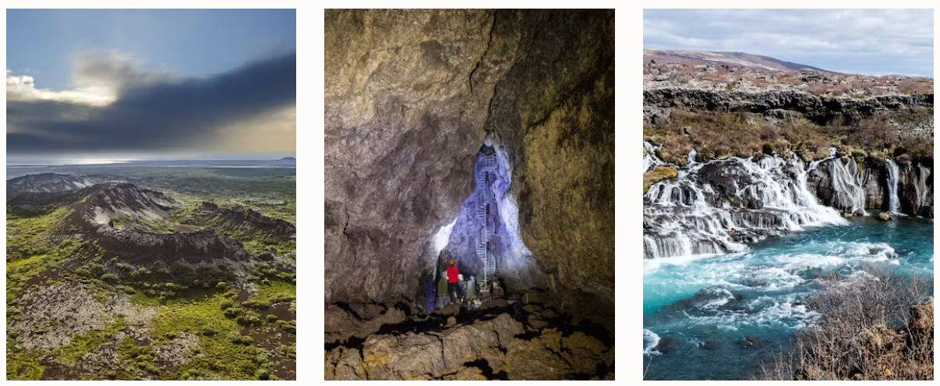

#### **SNÆFELLSJÖKULL NATIONAL PARK AND SNÆFELLSNES PENINSULA**

Snæfellsnes peninsula offers beautiful nature and was given the Earth Check certification in 2008 for working towards sustainability. The magnificent landscape and wildlife at [Snæfellsjökull National Park](https://www.visiticeland.com/article/snaefellsjokull-national-park" \t "_blank)is Iceland's only national park that reaches the sea. The mystical ice-capped volcano Snæfellsjökull has inspired artists and poets through the centuries. Snæfellsjökull is the setting of Jules Verne'sJourney to the center of the EarthandChristianity under the Glacierby the Icelandic Nobel prize novelist Halldór Laxness.

A visit to the [Vatnshellir lava tube cave](https://www.summitguides.is/vatnshellir-cave-op1r6" \t "_blank)and a [snow-cat tour on top of the volcano](https://sfn.is/tours/snaefellsjokull-glacier-snow-cat-tour/)are a few of the many options to explore the National park. Ytri-Tunga seal lair, the Shark museum at Bjarnarhöfn, the Búðir black church and Kirkjufell church-mountain are some of the most popular locations in Snæfellsnes peninsula.

From Snæfellsnes, you can cross over to **Dalir**, the cradle of the great explorers Eirík the Red and his son, Leif the Lucky, the first European to set foot in America. The short distances between popular destinations make it possible to enjoy the area at a comfortable pace all year round, so remember to slow down in West Iceland.