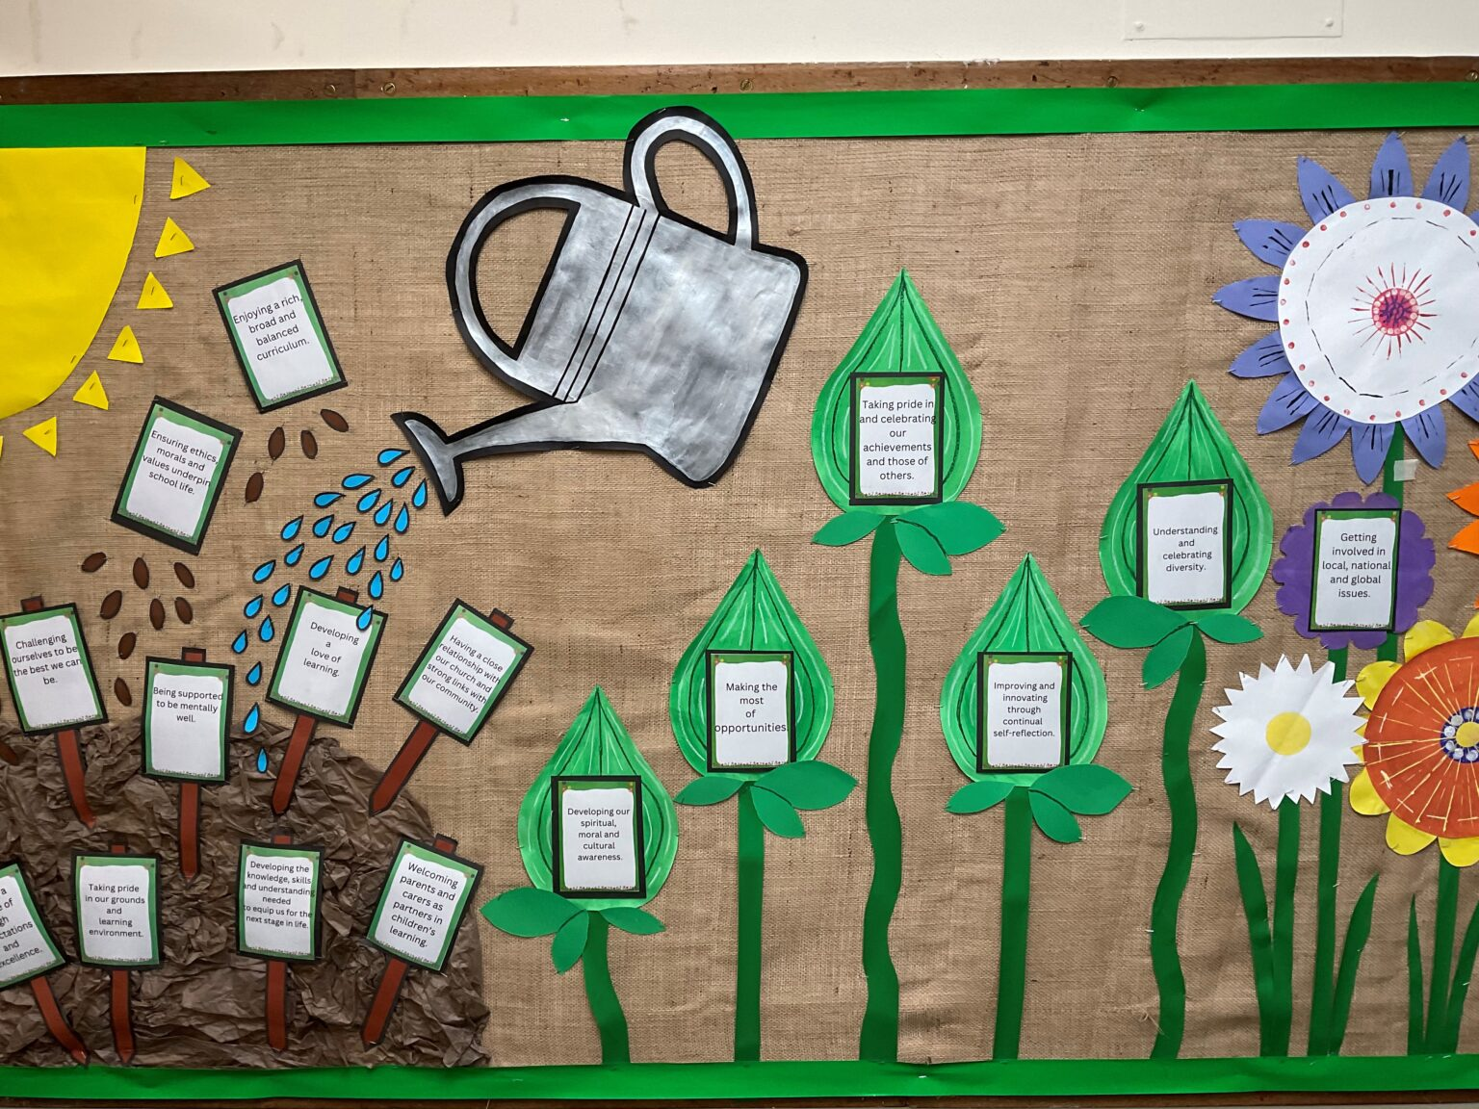

*Christ Church CE Primary School*

Pupil Premium Policy

2024 - 2025

Together we learn – Together we grow – Together we flourish

**`Some seeds fell on good earth and produced a harvest beyond wildest dreams.’**

**Matthew 13:8**

**Our Vision Statement**

Life at Christ Church is underpinned by the Christian values of **community**, **respect** and **stewardship** which help us to all:

Learn by;

* Feeling and being safe and happy in our school and its grounds
* Developing a love of learning
* Enjoying a rich, broad and balanced curriculum
* Challenging ourselves to be the best we can be
* Being supported to be mentally well
* Ensuring ethics, morals and values underpin school life
* Having a culture of high expectations and excellence.
* Welcoming parents and carers as partners in children’s learning.
* Having a close relationship with our Church and strong links with our community.
* Taking pride in our grounds and learning environment.
* Learning from each other and sharing best practice.
* Developing the knowledge, skills and understanding needed to equip us for the next stage in life
* Understanding and learning how to be a good citizen.

Grow by;

* Understanding and celebrating diversity
* Developing our spiritual, moral and cultural awareness
* Improving and innovating through continual self-reflection
* Making the most of opportunities
* Taking pride in and celebrating our achievements and those of others

Flourish by;

* Getting involved in local, national and global issues
* Experiencing exciting and enjoyable wider experiences
* Becoming caretakers of the world.

Together we learn – Together we grow – Together we flourish

**`Some seeds fell on good earth and produced a harvest beyond wildest dreams.’**

**Matthew 13:8**

At Christ Church CE Primary School we believe that all pupils should achieve their full potential and benefit from enjoyable learning experiences, whatever their background or circumstances. We pride ourselves on realising that every pupil in our school is unique, and therefore we need to make sure that all our activities reach out to each and every pupil.

**Legislation and Guidance**.

This policy is based on the pupil premium [allocations and conditions of grant guidance 2024 to 2025](https://www.gov.uk/government/publications/pupil-premium-allocations-and-conditions-of-grant-2024-to-2025), published by the Education and Skills Funding Agency (ESFA). It is also based on guidance from the Department for Education (DfE) on [using the pupil premium](https://www.gov.uk/government/publications/pupil-premium), [virtual school heads’ responsibilities concerning the pupil premium](https://www.gov.uk/guidance/pupil-premium-virtual-school-heads-responsibilities), and the [service pupil premium](https://www.gov.uk/guidance/service-premium-information-for-schools).

**Purpose of Pupil Premium.**

The pupil premium grant is additional funding allocated to publicly funded schools to raise the attainment of disadvantaged pupils and support pupils with parents in the armed forces.

The school will use the grant to support these groups, which comprise pupils with a range of different abilities, to narrow any achievement gaps between them and their peers.

We also recognise that not all pupils eligible for pupil premium funding will have lower attainment than their peers. In such cases, the grant will be used to help improve pupils’ progress and attainment so they can reach their full potential.

**Aims**

The targeted and strategic use of pupil premium will support us in achieving our vision for all disadvantaged pupils, which is to close the attainment gap between them and their peers.

**Principles**

* We ensure that teaching and learning opportunities meet the needs of all the pupils.
* We ensure that appropriate provision is made for pupils who belong to vulnerable groups. This includes ensuring that the needs of socially disadvantaged pupils are adequately assessed and addressed.
* In making provision for socially disadvantaged pupils, we recognise that not all pupils who receive free school meals will be socially disadvantaged.
* We also recognise that not all pupils who are socially disadvantaged are registered for or qualify for free school meals. We reserve the right to allocate the Pupils Premium funding to support any pupil, or groups of pupils, the school has legitimately identified as being socially disadvantaged. The greater proportion of any group, supported through Pupil Premium funding will be made up of disadvantaged pupils.
* Pupil premium funding will be allocated following a needs analysis which will identify priority classes, groups or individuals.
* Due to the continual nature of the teaching, assessment and learning cycle, not all pupils receiving free school meals will be in receipt of pupil premium interventions at all times.
* Pupil premium funding will also be allocated to looked after pupils and those who are the children of member of the Armed Forces.
* To make a significant impact on the education and lives of these pupils.
* To work in partnership with the parents of pupils to collectively ensure pupils’ success.

**Eligible Pupils.**

The pupil premium is allocated to the school based on the number of eligible pupils between Reception and Year 6.

Eligible pupils fall into the categories explained below.

Ever 6 free school meals

Pupils recorded in the most recent October school census who are known to have been eligible for free school meals (FSM) at any point in the last 6 years (as determined by the DfE’s latest conditions of grant guidance).

This includes pupils first known to be eligible for free school meals in the most recent October census.

This also includes pupils with no recourse to public funds (NRPF). The government has permanently extended FSM eligibility to include children in all households with NRPF.

It does not include pupils who received universal infant free school meals but would not have otherwise received free lunches.

Looked-after children

Pupils who are in the care of, or provided with accommodation by, a local authority in England or Wales for at least 1 day. Allocations will be provisionally based on the children looked after data return in March of the previous year, and then confirmed in December of the current year based on the children looked after data return in March of the current year.

Previously looked-after children

Pupils recorded in the most recent October census who:

* Were looked after by a local authority or other state care immediately before being adopted, or
* Left local authority or other state care on a special guardianship order or child arrangements order

This includes children adopted from state care or equivalent from outside England and Wales.

Ever 6 Service Children

Pupils recorded in the most recent October census:

* With a parent serving in the regular armed forces
* Who have been registered as a ‘service child’ in the school census at any point in the last 6 years (as determined by the DfE’s latest conditions of grant guidance), including those first recorded as such in the most recent October census
* In receipt of a child pension from the Ministry of Defence because 1 of their parents died while serving in the armed forces

**Funding for Academic Year 2024 -2025.**

|  |  |
| --- | --- |
| **Disadvantaged pupils** | **PPG amount per pupil** |
| Pupils in Reception to Year 6 recorded as ‘Ever 6 FSM’ | £1,455 |
| **Service children** | **Grant amount per pupil** |
| Any pupil in Reception to Year 11 recorded as an ‘Ever 6 service child’ or in receipt of a child pension from the MoD | £340 |

**Our Tiered Approach**

To prioritise spending, we have adopted a tiered approach to define our priorities and ensure balance. Our tiered approach comprises three categories:

1. Teaching
2. Targeted academic support
3. Wider strategies

Within each category, we have chosen three interventions. This focussed approach ensures the best chance of success for each intervention.

**Quality of teaching**

1. Encouraging self-led professional development: Introducing a half-hour weekly CPD slot for teaching staff
2. Professional development: Weekly individual coaching sessions to support teachers, with a particular emphasis on literacy and vocabulary
3. Support for early career teachers: A termly one-day teaching development programme delivered by external experts

**Targeted academic support**

1. Structured interventions: Introducing vocabulary interventions for pupils with poor oral language and communication skills
2. Small group tuition: Introducing targeted English and maths teaching for pupils who are below age-related expectations
3. One-to-one support for disadvantaged pupils: Creating additional teaching and learning opportunities using TAs

**Wider strategies**

1. Parental engagement: Providing transport for parents to attend annual reviews
2. Readiness to learn: Introduction of a breakfast club to provide pupils with a nutritious breakfast before school
3. Attendance: Use of an Education Welfare Officer (EWO) two days per week to improve attendance and foster links with parents

**Provision**

The range of provision the Leadership Team and Governing Body will consider making for this group could include:

* Providing small group work with an experienced teacher focussed on overcoming gaps in learning.
* 1:1 support.
* Additional teaching and learning opportunities provided by trained Teaching Assistants or external agencies, including the funding of training to support these opportunities.
* Resources to meet the need of particular individuals or groups of pupils.
* Memorable opportunities created for pupils.
* Developing parental engagement and aspirations.
* Cultural enrichment.
* Emotional support.

All our work through the Pupil Premium will be aimed at accelerating progress, moving disadvantaged pupils to at least age related expectations and matching the attainment of their peers.

Pupil premium resources may also be used to target able pupils on Free School Meals to achieve a higher score or greater depth at the end of Key Stage 1 and Key Stage 2.

The Leadership Team will seek to engage with teaching staff and parents/carers to tailor the provision offered to meet the needs of individual pupils.

**How will we make decisions regarding the use of the Pupil Premium?**

In making decisions on the use of the Pupil Premium we will:

* Ensure that the pupil premium funding allocated to our school used solely for its intended purpose.
* Use the latest evidence based research on proven strategies which work to narrow the attainment gap and adapt these as necessary to meet the needs of our pupils.
* Be transparent in our reporting of how we have used the Pupil Premium, so that members of our school community and Ofsted are fully aware of how this additional resource has been used to make a difference.
* Encourage the take up of Free School Meals by working proactively with our parents and carers in a sensitive and supportive manner and to remove any potential barriers or stigma attached to claiming Free School Meals. In doing so we recognise the vital role that parents and carers play in the lives of their pupils.
* Ensure that there is robust monitoring and evaluation in place to account for the use of Pupil Premium by the school and Governing Body.

**Reporting**

It will be the responsibility of the Headteacher, or a delegated member of staff, to include the following information in the annual report for the Governors:

* The progress made towards narrowing the gap, by year group, for socially disadvantaged pupils.
* An outline of the provision that was made since the last annual report.
* An evaluation of the cost effectiveness, in terms of the progress made by the pupils receiving a particular provision, when compared with other forms of support.

At the end of the academic year, the Governors of the school will ensure that there is an annual statement to parents on how the pupils premium funding has been used to address the issues of `narrowing the gap’, for socially disadvantaged pupils. This task will be carried out within the requirements published by the Department of Education.

**Evaluation and success criteria.**

The evaluation of this policy is based on how quickly the school can `close the gap’ between socially disadvantaged pupils and their peers.

The success criteria of the pupil premium policy are;

* Early intervention and support for socially disadvantaged pupils.
* The vast majority of socially disadvantaged children will meet their individual targets.
* Effective parental-pupil school support.
* Having an effective system for identifying, assessing and monitoring pupils.
* Having a whole-school approach.
* Creating a positive school atmosphere in which pupils’ differences are recognised and valued as full members of the school community.
* Developing confident and independent learners.
* Parents are engaged and involved in their children’s learning.

**Links to other polices and documentation**.

Although this policy is the key document outlining our approach to narrowing the gaps in attainment and achievement for our disadvantaged pupils, we will, however, ensure that information about our responsibilities under the Equality Act 2010 for other pupils for whom narrowing the gap remains an issue but are not covered by the Pupil Premium, are also included in key documents such our School Improvement Plan, self-evaluation review, the school prospectus, school website and newsletters.

This policy should be read in conjunction with the Pupil Premium plan published on the school website.

**Monitoring and reviewing the policy.**

Our work in relation to the Pupil Premium will be reviewed on a termly basis to ensure it is having the intended impact in narrowing the gaps. This will allow us to make adjustments if particular strategies are not working well.

Our Pupil Premium action plan will be reviewed on an annual basis and any necessary policy changes will me made thereafter, taking into consideration any changes to the funding that is made available under the Pupil Premium grant.

# Roles and responsibilities.

6.1 Headteacher and senior leadership team

The headteacher and senior leadership team are responsible for:

* Keeping this policy up to date, and ensuring it is implemented across the school
* Ensuring all school staff are aware of their role in raising the attainment of disadvantaged pupils and supporting pupils with parents in the armed forces
* Planning pupil premium spending and keeping this under constant review, using an evidence-based approach and working with virtual school heads where appropriate
* Monitoring the attainment and progress of pupils eligible for the pupil premium to assess the impact of the school’s use of the funding
* Reporting on the impact of pupil premium spending to the governing board on an ongoing basis
* Publishing the pupil premium strategy statement on the school’s use of the pupil premium in each academic year on the school website, in line with the DfE’s [guidance on using the pupil premium](https://www.gov.uk/government/publications/pupil-premium) and using the templates on GOV.UK.
* Providing relevant training for staff, as necessary, on supporting disadvantaged pupils and raising attainment

Governors

The governing board is responsible for:

* Holding the headteacher to account for the implementation of this policy
* Ensuring the school is using pupil premium funding appropriately, in line with the rules set out in the conditions of grant
* Monitoring the attainment and progress of pupils eligible for the pupil premium, in conjunction with the headteacher, to assess the impact and effectiveness of the school’s use of the funding
* Monitoring whether the school is ensuring value for money in its use of the pupil premium
* Challenging the headteacher to use the pupil premium in the most effective way
* Setting the school’s ethos and values around supporting disadvantaged members of the school community

Other school staff

All school staff are responsible for:

* Implementing this policy on a day-to-day basis
* Setting high expectations for all pupils, including those eligible for the pupil premium
* Identifying pupils whose attainment is not improving in response to interventions funded by the pupil premium, and highlighting these individuals to the senior leadership team
* Sharing insights into effective practice with other school staff

Virtual school heads

Virtual school heads are responsible for managing pupil premium funding for children looked after by a local authority and allocating it to schools. Their responsibilities include, but are not limited to:

* Identifying the eligible looked-after children and informing the local authority
* Making sure methods for allocating and spending ensure that looked-after children benefit without delay
* Working with each looked-after child’s educational setting to put together a personal education plan, agree how pupil premium funding will be spent to meet the need identified in this plan, and ensure the funding is spent in this way
* Demonstrating how pupil premium funding is raising the achievement of looked-after children

Virtual school heads are in charge of promoting the educational achievement of all the children looked after by the local authority they work for.